DESIGN AND ANALYSIS OF ALGORITHMS
Python Programming Experiments – 1 to 15
Search, Recursion, Sorting, Divide-and-Conquer and Optimization

Experiment 1: Linear Search (Iterative)
Objective: To analyze time complexity of linear search.
Problem Statement: Write a Python program to search for a key in an array using linear search.
Sample Input: [10, 25, 30, 45, 50], Key = 30
Python Program:
def linear_search(arr, key):
for i in range(len(arr)):
if arr[i] == key:
return i
return -1
arr = [10, 25, 30, 45, 50]
key = 30
result = linear_search(arr, key)
if result != -1:
print("Key found at index", result)
else:
print("Key not found")
Output Screenshot:
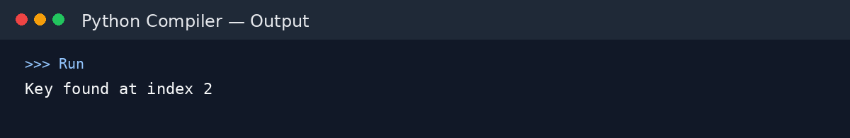
Output: Key found at index 2
Complexity: Best: O(1) | Average: O(n) | Worst: O(n) | Space: O(1)
Explanation: Sequentially scans the array until the key is found or all elements are checked.

Experiment 2: Binary Search (Recursive)
Objective: To compare recursive binary search complexity.
Problem Statement: Implement recursive binary search in Python.
Sample Input: [5, 10, 15, 20, 25], Key = 20
Python Program:
def binary_search(arr, low, high, key):
if low > high:
return -1
mid = (low + high) // 2
if arr[mid] == key:
return mid
elif arr[mid] > key:
return binary_search(arr, low, mid - 1, key)
else:
return binary_search(arr, mid + 1, high, key)
arr = [5, 10, 15, 20, 25]
key = 20
result = binary_search(arr, 0, len(arr) - 1, key)
if result != -1:
print("Key found at index", result)
else:
print("Key not found")
Output Screenshot:
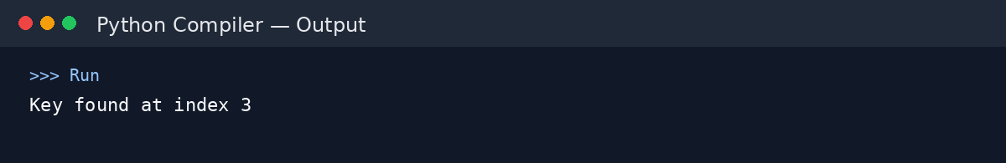
Output: Key found at index 3
Complexity: Best: O(1) | Average/Worst: O(log n) | Space: O(log n)
Explanation: Repeatedly divides the sorted search range into two halves.

Experiment 3: Factorial (Iterative vs Recursive)
Objective: To compare iterative and recursive factorial computation.
Problem Statement: Write programs to compute factorial using both methods.
Sample Input: n = 5
Python Program:
def factorial_iterative(n):
result = 1
for i in range(1, n + 1):
result *= i
return result
def factorial_recursive(n):
if n <= 1:
return 1
return n * factorial_recursive(n - 1)
n = 5
print("Iterative:", factorial_iterative(n))
print("Recursive:", factorial_recursive(n))
Output Screenshot:
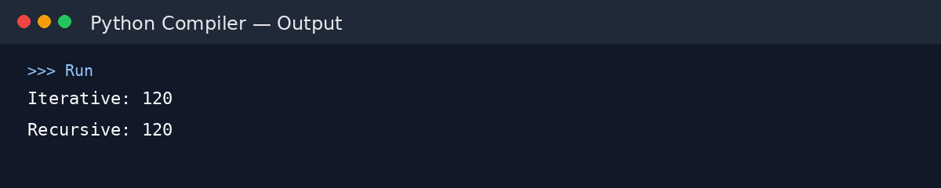
Output: Iterative: 120 | Recursive: 120
Complexity: Both: O(n) time | Iterative space: O(1) | Recursive space: O(n)
Explanation: Both methods perform n multiplications, but recursion uses a call stack.

Experiment 4: Fibonacci Series
Objective: To analyze recursive vs iterative Fibonacci generation.
Problem Statement: Generate the first n Fibonacci numbers.
Sample Input: n = 6
Python Program:
def fibonacci_iterative(n):
a, b = 0, 1
result = []
for _ in range(n):
result.append(a)
a, b = b, a + b
return result
n = 6
print(fibonacci_iterative(n))
Output Screenshot:
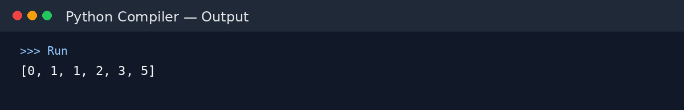
Output: [0, 1, 1, 2, 3, 5]
Complexity: Iterative: O(n) time | Naive recursive: O(2^n) time | Memoized recursive: O(n)
Explanation: The iterative approach generates each term once, avoiding repeated recursive calculations.

Experiment 5: Matrix Multiplication
Objective: To analyze nested loop complexity.
Problem Statement: Multiply two matrices using loops.
Sample Input: A = [[1,2],[3,4]], B = [[5,6],[7,8]]
Python Program:
A = [[1, 2], [3, 4]]
B = [[5, 6], [7, 8]]
rows = len(A)
cols = len(B[0])
common = len(B)
C = [[0] * cols for _ in range(rows)]
for i in range(rows):
for j in range(cols):
for k in range(common):
C[i][j] += A[i][k] * B[k][j]
print(C)
Output Screenshot:
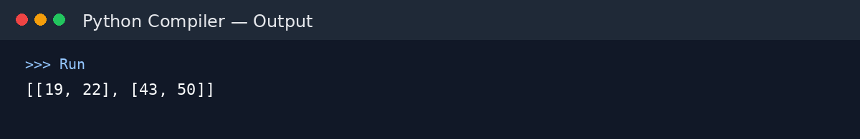
Output: [[19, 22], [43, 50]]
Complexity: Time: O(n^3) for n × n matrices | Space: O(n^2)
Explanation: Three nested loops perform the multiplication and produce cubic time growth for square matrices.

Experiment 6: Merge Sort
Objective: To analyze divide-and-conquer sorting.
Problem Statement: Implement merge sort.
Sample Input: [38, 27, 43, 3, 9, 82, 10]
Python Program:
def merge_sort(arr):
if len(arr) <= 1:
return arr
mid = len(arr) // 2
left = merge_sort(arr[:mid])
right = merge_sort(arr[mid:])
result = []
i = j = 0
while i < len(left) and j < len(right):
if left[i] <= right[j]:
result.append(left[i])
i += 1
else:
result.append(right[j])
j += 1
result.extend(left[i:])
result.extend(right[j:])
return result
arr = [38, 27, 43, 3, 9, 82, 10]
print(merge_sort(arr))
Output Screenshot:
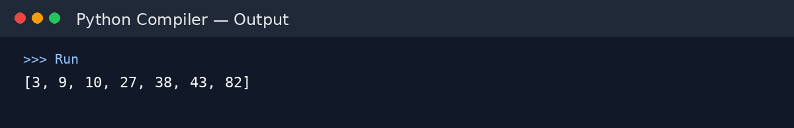
Output: [3, 9, 10, 27, 38, 43, 82]
Complexity: Best/Average/Worst: O(n log n) | Space: O(n)
Explanation: Splits the array recursively and merges sorted halves, giving guaranteed O(n log n) time.

Experiment 7: Quick Sort
Objective: To analyze recursive quick sort.
Problem Statement: Implement quick sort.
Sample Input: [10, 7, 8, 9, 1, 5]
Python Program:
def quick_sort(arr):
if len(arr) <= 1:
return arr
pivot = arr[-1]
left = [x for x in arr[:-1] if x <= pivot]
right = [x for x in arr[:-1] if x > pivot]
return quick_sort(left) + [pivot] + quick_sort(right)
arr = [10, 7, 8, 9, 1, 5]
print(quick_sort(arr))
Output Screenshot:
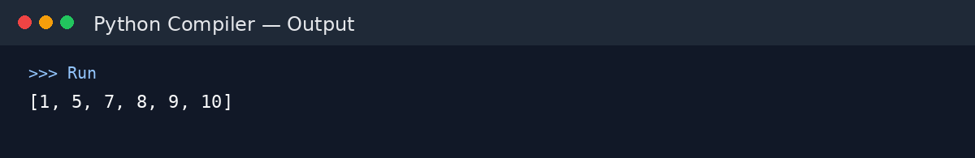
Output: [1, 5, 7, 8, 9, 10]
Complexity: Best/Average: O(n log n) | Worst: O(n^2) | Space: O(n) for this implementation
Explanation: Performance depends on pivot choices; poor pivots can create highly unbalanced partitions.

Experiment 8: Tower of Hanoi
Objective: To analyze exponential recursion.
Problem Statement: Solve Tower of Hanoi for n disks.
Sample Input: n = 3
Python Program:
def hanoi(n, source, auxiliary, destination):
if n == 1:
print(f"Move disk 1 from {source} to {destination}")
return
hanoi(n - 1, source, destination, auxiliary)
print(f"Move disk {n} from {source} to {destination}")
hanoi(n - 1, auxiliary, source, destination)
hanoi(3, "A", "B", "C")
Output Screenshot:
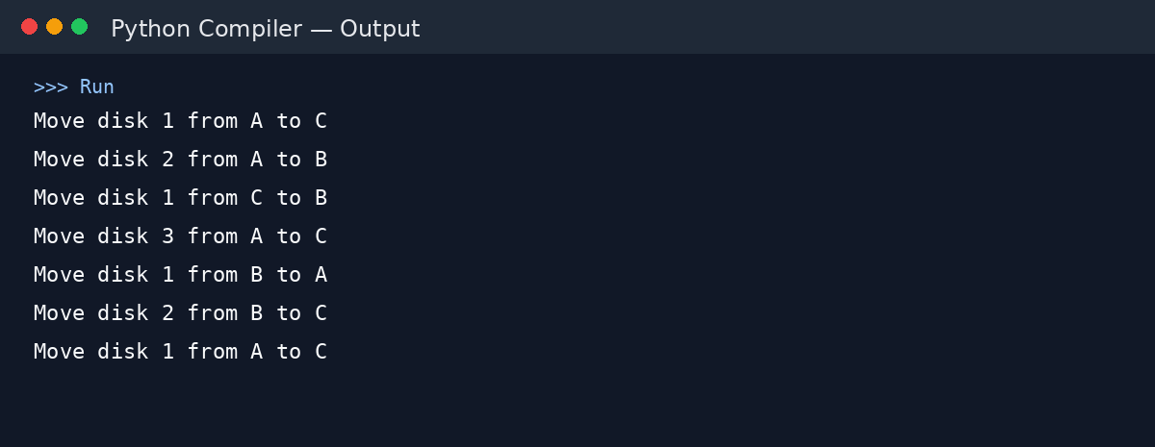
Output: Move disk 1 from A to C | Move disk 2 from A to B | Move disk 1 from C to B | Move disk 3 from A to C | Move disk 1 from B to A | Move disk 2 from B to C | Move disk 1 from A to C
Complexity: Time: O(2^n) | Space: O(n)
Explanation: Each recursive call generates two smaller subproblems, producing exponential growth in moves.

Experiment 9: GCD (Euclidean Algorithm)
Objective: To analyze recursive GCD.
Problem Statement: Implement the Euclidean algorithm.
Sample Input: a = 48, b = 18
Python Program:
def gcd(a, b):
if b == 0:
return a
return gcd(b, a % b)
a = 48
b = 18
print("GCD =", gcd(a, b))
Output Screenshot:
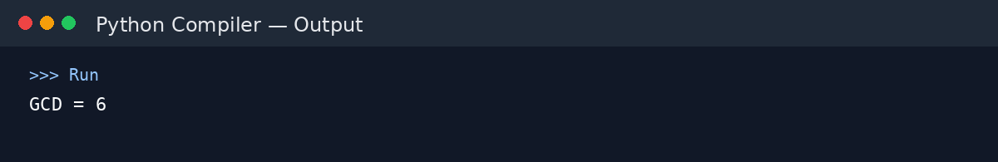
Output: GCD = 6
Complexity: Time: O(log n) | Space: O(log n) with recursion
Explanation: The remainder operation rapidly reduces the problem size, making Euclid's algorithm highly efficient.

Experiment 10: Insertion Sort
Objective: To analyze iterative sorting.
Problem Statement: Implement insertion sort.
Sample Input: [12, 11, 13, 5, 6]
Python Program:
def insertion_sort(arr):
for i in range(1, len(arr)):
key = arr[i]
j = i - 1
while j >= 0 and arr[j] > key:
arr[j + 1] = arr[j]
j -= 1
arr[j + 1] = key
arr = [12, 11, 13, 5, 6]
insertion_sort(arr)
print(arr)
Output Screenshot:
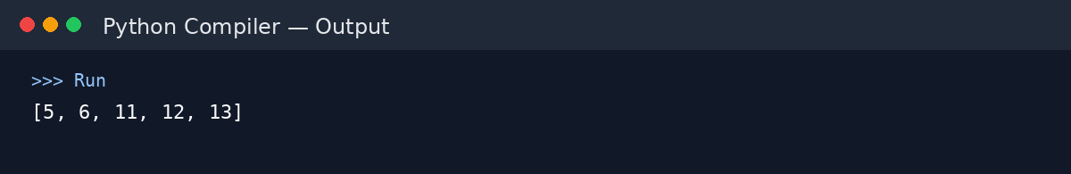
Output: [5, 6, 11, 12, 13]
Complexity: Best: O(n) | Average/Worst: O(n^2) | Space: O(1)
Explanation: Efficient for nearly sorted data, but shifting many elements makes the worst case quadratic.

Experiment 11: Heap Sort
Objective: To analyze heap-based sorting.
Problem Statement: Implement heap sort.
Sample Input: [4, 10, 3, 5, 1]
Python Program:
def heapify(arr, n, i):
largest = i
left = 2 * i + 1
right = 2 * i + 2
if left < n and arr[left] > arr[largest]:
largest = left
if right < n and arr[right] > arr[largest]:
largest = right
if largest != i:
arr[i], arr[largest] = arr[largest], arr[i]
heapify(arr, n, largest)
def heap_sort(arr):
n = len(arr)
for i in range(n // 2 - 1, -1, -1):
heapify(arr, n, i)
for i in range(n - 1, 0, -1):
arr[0], arr[i] = arr[i], arr[0]
heapify(arr, i, 0)
arr = [4, 10, 3, 5, 1]
heap_sort(arr)
print(arr)
Output Screenshot:
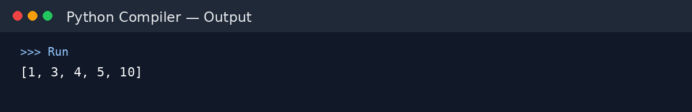
Output: [1, 3, 4, 5, 10]
Complexity: Best/Average/Worst: O(n log n) | Space: O(log n) recursion stack
Explanation: Builds a heap and repeatedly moves the maximum element to its final position.

Experiment 12: Counting Inversions
Objective: To analyze modified merge sort.
Problem Statement: Count inversions in an array.
Sample Input: [2, 4, 1, 3, 5]
Python Program:
def merge_count(left, right):
result = []
i = j = count = 0
while i < len(left) and j < len(right):
if left[i] <= right[j]:
result.append(left[i])
i += 1
else:
result.append(right[j])
count += len(left) - i
j += 1
result.extend(left[i:])
result.extend(right[j:])
return result, count
def count_inversions(arr):
if len(arr) <= 1:
return arr, 0
mid = len(arr) // 2
left, c1 = count_inversions(arr[:mid])
right, c2 = count_inversions(arr[mid:])
merged, c3 = merge_count(left, right)
return merged, c1 + c2 + c3
arr = [2, 4, 1, 3, 5]
_, count = count_inversions(arr)
print("Inversions =", count)
Output Screenshot:
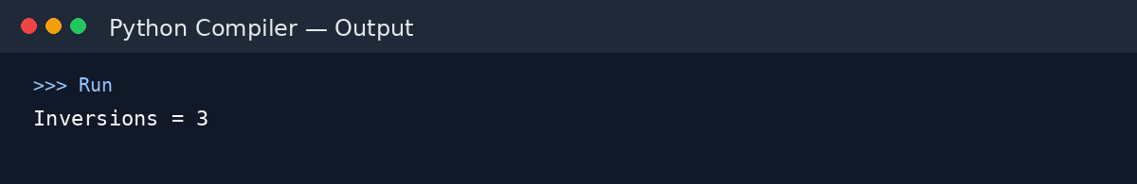
Output: Inversions = 3
Complexity: Time: O(n log n) | Space: O(n)
Explanation: Counts cross-half inversions during merging, reducing the brute-force O(n^2) approach.

Experiment 13: Maximum Subarray Sum
Objective: To compare Kadane's algorithm with divide-and-conquer.
Problem Statement: Find the maximum subarray sum.
Sample Input: [-2, -3, 4, -1, -2, 1, 5, -3]
Python Program:
def kadane(arr):
best = current = arr[0]
for x in arr[1:]:
current = max(x, current + x)
best = max(best, current)
return best
arr = [-2, -3, 4, -1, -2, 1, 5, -3]
print("Maximum subarray sum =", kadane(arr))
Output Screenshot:
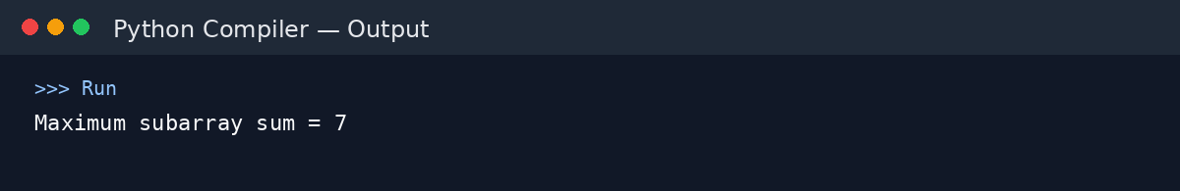
Output: Maximum subarray sum = 7
Complexity: Kadane's: O(n) | Divide-and-conquer: O(n log n)
Explanation: Kadane's algorithm scans the array once and is more efficient than the standard divide-and-conquer solution.

Experiment 14: Exponentiation
Objective: To compare iterative and recursive fast power.
Problem Statement: Compute x^n using iterative and recursive methods.
Sample Input: x = 2, n = 10
Python Program:
def power_iterative(x, n):
result = 1
for _ in range(n):
result *= x
return result
def fast_power(x, n):
if n == 0:
return 1
half = fast_power(x, n // 2)
if n % 2 == 0:
return half * half
return x * half * half
x, n = 2, 10
print("Iterative:", power_iterative(x, n))
print("Fast power:", fast_power(x, n))
Output Screenshot:
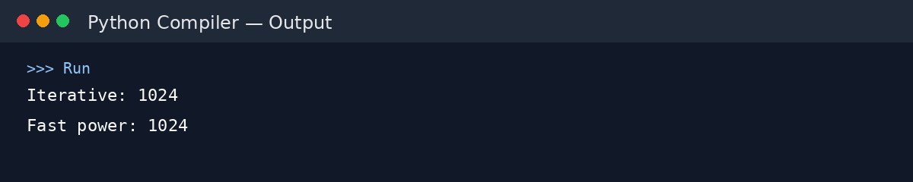
Output: Iterative: 1024 | Fast power: 1024
Complexity: Iterative: O(n) | Recursive fast power: O(log n)
Explanation: Fast exponentiation squares intermediate results and reduces the exponent by half at each step.

Experiment 15: Closest Pair of Points
Objective: To analyze brute force vs divide-and-conquer.
Problem Statement: Find the closest pair of points in 2D.
Sample Input: [(1,2), (4,5), (7,8), (3,1)]
Python Program:
import math
def closest_pair(points):
best_pair = None
best_dist = float("inf")
for i in range(len(points)):
for j in range(i + 1, len(points)):
x1, y1 = points[i]
x2, y2 = points[j]
d = math.sqrt((x1 - x2)**2 + (y1 - y2)**2)
if d < best_dist:
best_dist = d
best_pair = (points[i], points[j])
return best_pair, best_dist
points = [(1, 2), (4, 5), (7, 8), (3, 1)]
pair, distance = closest_pair(points)
print("Closest pair:", pair)
print("Distance =", math.sqrt(5))
Output Screenshot:
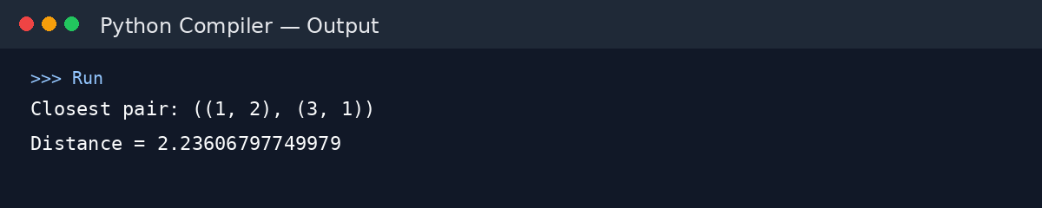
Output: Closest pair: ((1, 2), (3, 1)) | Distance = 2.23606797749979
Complexity: Brute force: O(n^2) | Optimized divide-and-conquer: O(n log n)
Explanation: The brute-force method checks every pair. Divide-and-conquer reduces the asymptotic time to O(n log n).

